Thesis Proposal:   
 Developing an ABAC based Grant Proposal Workflow Management System

Milson Munakami

[milsonmunakami@u.boisestate.edu](mailto:milsonmunakami@u.boisestate.edu)

Boise State University

April 15, 2016

# Introduction

With the advancement of Web infrastructures and technologies such as cloud computing, Big Data, Bring Your Own Device (BYOD), Internet of Things(IoT), distributed systems and web services, etc., organizations are trying to adopt such new trends to develop and implement autonomous workflow management systems (WfMSs). By leveraging the benefits of such advanced and cutting-edge, innovative information technology, it is bringing a new paradigm shift in the organization breaking the traditional approach of manual paper-based workflow management. Primarily, such online WfMSs focus on helping people to perform their tasks better and faster. However, the same level of security and automation is required by the organization along with promoting collaboration and information sharing among its stakeholders. As such fast-paced business processes are automated commonly referred as ‘workflow automation’ many security challenges need to be considered to streamline the work associated with each process step to make it more secure and flexible. Such dynamic and adaptive WfMS needs to provide a way to adopt the vibrant and more changing organizational need both functional and security requirements. Additionally, it also needs to offer customers the ability to focus on work and improve business operations rather than managing and tackling new information security challenges associated with each task.

To accomplish security requirements of any adaptive workflows, we can implement access control mechanisms [1][2][3]. According to National Institute of Standards and Technology (NIST) - “*An access control method where subject requests to perform operations on objects are granted or denied based on assigned attributes of the subject, assigned attributes of the object, environment conditions, and a set of policies that are specified in terms of those attributes and conditions.*” [4]. Access control is always necessary for organizations to offer proper data security and protection which is even more crucial to secure critical assets of distributed workflow system that deals with multi-users and the multi-objects environment. In recent year, many secure access control models [2][5][6][7] have been proposed and studied for collaborative and intra-organizational environments that express complicated access control constraint using traditional security methods. Unfortunately, those old static access control models radically fail to meet new regulatory and compliance demand of a real-world organization. In particular, the majority of available workflow systems do not yet support external authorization. In these models, access is defined and controlled by each application’s backend database or via hard-wiring within code-level which can make them harder to address the dynamic organizational changes and restructuring processes. Contemporary information security mechanisms are often immature or insufficient in addressing such demanding compliances. To make such WfMS more secure and maintainable, we need to separate clearly the business logic from the security features so that authorization logics do not need to be managed within the code rather can be created and maintained external to the application.

However, with this separation of authority and business process; modeling, composing and testing of such application become harder and time-extensive. Workflow processes can be complex and deal with more sensitive data across many different users that require varying degrees of information privacy and data security mechanisms. Any organization demands interactions and collaborations among numerous distributed users and a diverse set of corporate settings and resources with pre-defined individual user level access rights. As it involves diverse and distributed stakeholders accessing the same resources from different environments and ‘context’ that is beyond the predefined organizational boundaries in such application, there is always a risk associated with sensitive information disclosure, unauthorized data access and lack of privacy protection. Such workflow applications need to provide a way to control the access to the information based on both user’s authority levels and various implicit contexts.

Using autonomous workflow systems can leverage significant advantages to organizations by way of reduced paperwork and accelerated the flow of document-centric information through automatic electronic documentation routing and better Quality of Service (QoS) to their users. To fulfill and address such fundamental driving force behind each organization we need to have a firm understanding of their business objectives as well as security requirements. By adopting such digital transformation, we face several challenges such as automation and security managements alongside we need to take account of different access control constraints. Any workflow management system has to manage and execute each workflow operations in a very secure and flexible way. In a workflow, Security involves the implementation of a secure access control mechanisms to ensure that no subjects are allowed to perform unauthorized activities. However, the biggest problem is such objects can have dynamic attributes and characteristics based on the context of the workflow status.

The increasing interest in replacing paper-based workflow into internet based online workflow systems make it vulnerable to security attacks and threats from outsiders. However, broad adoption of such system makes security, confidentiality and privacy issues more important to any organization using them as an integral part to manage their daily workflow. Each workflow steps can act as an entry point for potential security threats and attacks, such as any unauthorized access to the protected sensitive organizational information and leakage of user data. Such paradigm shift is increasing the complexity of workflow software architecture, design, and implementation. Hence, a more efficient and secure system design is needed to protect the immense flow of sensitive information flowing through such system from data theft.

# Thesis Statement

For this thesis work, we are going to implement Attribute-Based Access Control (ABAC) model with the new specification of Version 3.0 eXtensible Access Control Markup Language (XACML) standard that in a real-world application such as Grant Proposal Workflow Management System (GPWfMS). This research allows us to investigate into some of the advanced access control concepts like Delegation of Authority (DOA) and Obligation. Issues of DOA can cause a critical security threat to the business as it provisions more administrative authority to any new user in absence or consent of a primary delegator. Moreover, in current existing workflow systems, there is no way we can enforce Obligations on any users.

In GPWfMS, we try to capture the real-world workflow process of University Grant Proposal Submission operation. In such workflow system the authorization and administration permissions are distributed to multiple administrative domains and administrative roles. The traditional centralized authorization and policy models in access control have many limitations that cannot fulfill the regulatory requirements of dynamic and adaptive collaboration environments. Thus, there is a great need for flexibility in software design and implementation that supports dynamic changing of security policies based on DOA and Obligation security constraints. Improper design and implementation of such access control security constraints may arise critical complications. These restriction issues within a workflow system will be explored within the context of the execution.

We propose a separation of code-based business logic and authorization policies by utilizing the XACML and making use of fine-grained access control model called ABAC. This model combines the advantages of the new fine-grained ABAC model along with other security access control constraints. By this separation of logics, we can achieve more fine-grained control of those policies, and also changes in business logic are easy to implement and administer which helps to avoid the costly task of recoding and reconfiguring when business policies change thus allowing more flexible control over security. These capabilities offered by ABAC enable truly fine-grained and dynamic authorization that can be made context-aware and risk intelligent.

# Motivation

The workflow industry is still maturing, and in many cases, definitions for terms used by various vendors of workflow systems have not been consolidated. The first standardization effort was made by Workflow Management Coalition (WfMC) which is an international non-profit organization, founded in August 1993 with the objectives of excelling the opportunities for workflow technology through the standardization of common terminology and specifications. Workflow systems can achieve a level of interoperability by using common specifications for standard functions, and that can be beneficial to both vendors and users of such technology. According to its definition, “*The automation of a business process, in whole or part, during which documents, information or tasks are passed from one participant to another for action, according to a set of procedural rules*” [8]. The WfMC has published a security workflow Model, describing some security services that includes authentication, authorization, access control, data privacy, audit, data privacy, data integrity and non-repudiation which clearly emphasizes the major security objective of any workflow system be to prevent the unauthorized access of classified information. On the other hand, this paper [9] presents a chronology overview of the evolution of workflow management systems and their definitions, classifications, and available tools.

In the study of workflow secure access control models, the task-based access control (TBAC) and role-based access control (RBAC) are most commonly considered and applied [10]. As WfMSs are used for critical and strategic applications, security is an essential and fundamental part of such systems. Many Web-based workflow applications enhance their safety via access control systems [1][2][3]. Our goal of this research work is to improve the existing secure software design model that mainly advocates for the use of TBAC, RBAC [10] and ABAC without the concept of DOA and Obligations. NIST[4] indicates ABAC as a recommended access control model for promoting information sharing among diverse and disparate organizations.

Today, workflow systems involved the automation of a business process involving more coordinated and collaborated execution of multiple tasks from different entities that may reside outside the inter-organizational boundaries at distributed environments. Such intra-boundaries access demands such system to support for continuous and collaborative business process improvements which put the business process immediately and directly under the control of the people using the system. With such improvements the problem of interoperability arises and to alleviate such problem; we need to adopt an efficient mechanism to establish trust among participants in a high-level abstraction. This survey [11] explains how platform-independent and flexible trust can be integrated so that workflow systems can interoperate in intra-organizational and distributed environments even though; the standard development is still immature.

Even though we are experiencing unprecedented popularity rise of WfMSs, very few efforts are done to take into account for access control constraints such as Separation of Duties (SoD), DOA and Obligations. The complexity of real-world workflow application requirements is revealing limitations of the current security model design. The available traditional security access models are more discretionary and do not consider contextual information such as date time and environments that make intruders easy to bypass any defined security mechanisms. One of the many outstanding technical challenges of adaptive WfMS is that it need to unify people and resources with diverse features into a more cohesive way.

In particular, we are going to investigate various security concerns in a complex environment of GPWfMS, which captures the real-world working process of Grant Proposal Submission. GPWfMS is a web-based workflow management system to automate and regulate the approval process of grant proposal submission which manages the creation, routing, and processing of grant proposals necessary to complete a transaction. Currently, the process of creating a research proposal and routing it for final submission is a very time-consuming and manual process as any proposal may require multiple users to review and approve it during various stages. This extensive process begins filling up much sensitive information as shown in proposal data sheet on Appendix VI. If such data is leaked it can cause a security risk to the whole organization. If we look into the existing proposal workflow systems, they are costly and close sourced which lack the agility to meet dynamic organizational needs regarding access control and automation. Either such state-of-art digital solutions have security access controls hardcoded within the code or do not specify the access control constraints such as DOA and Obligations in policy level. These limitations making such applications rigid, incomplete, less secure and easy target to the security threats. The primary focus of the security in such model is based on their role in the organization which can quickly restructure or revoked in dynamic enterprises which means again the code need to be reconfigured and modified which is more time and space consuming.

A secure online workflow system needs to compliance all security requirements of the organizations alongside their objectives and should safeguard all the sensitive information at any point of time. We can achieve this by integrating organizational access control policies throughout the workflow activities. However, this does not mean that it needs to imply many restrictive measures during each action from the user to make it more secure and robust. Such restrictions may degrade the usability or user acceptance of the overall system and also can impact the system’s performance.

In our service-oriented web-based Grant Proposal management system, the example of the proposed access control model defining the business activities in the workflow life cycle is as shown below 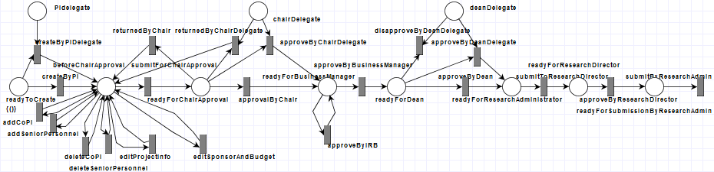

Figure 1 Proposal workflow life cycle

The process of approving a research proposal, grant submission, and authorization, however, can be time-consuming. There are numerous steps along the way for any research proposal to go from inception to final approval, and the most time-consuming factor can often be the length of time to reach a person and for that person to review the document. While making it more automated and web based we need to consider the possibility of having many ‘disconnected users’ who can obstruct the flow of the task.

As we can see in Figure 1 and UML diagrams in Appendix I, II and III, a research grant proposal is written and initiated by a Principal Investigator (PI). The proposal may include some Co-Principal Investigators (Co-PI) and Senior Personnel as co-authors or contributors. When the PI is ready for the proposal to be evaluated, she can submit it to a department chair for approval who will either return it or route it to the next phase in the workflow where it will await for being reviewed by the Business Manager, the Institutional Review Board (IRB) and the Dean. This process can get even more complex and complicated if the proposal involves investigators from multiple departments as all departments’ authoritative personnel need to review and approve the proposal content. Once the proposal is approved by the Dean as well as reviewed by IRB if it involves any compliance issues, then it must then be routed to the University Research Administrator who can disapprove or withdraw it or can approve it to be routed to University Research Director. Research Director can either refuse or delete the whole proposal or can give final approval for submission by the Research Administrator.

As we can see in above described standard scenario, it involves different activities that need users with various position titles and privileges to engage and complete various tasks. Each activity within the workflow is associated with a subject who needs to ensure the pending work is completed on time, and all obligations are fulfilled before and after any action is performed. To convert the manual process into a flexible, reliable and more secure digital automated system is a challenge which respects the integrity of the workflow as shown in Figure 1. We can view this complex workflow as a multi-layered state machine which needs to fulfill pre-conditions and post-conditions in each state and some specific event triggers it from one state to another. In particular, we are looking into a complex environment of GPWfMS which may involve various subjects trying to perform certain actions on different resources that can alter data and control flow. Thus, it requires verification and validation of the correct access to the resources using subject’s access levels which can be determined by subject and resource’s attributes. Attributes may be considered characteristics of entities that may be predefined and pre-assigned a value by an authority. Access level rules are created and evaluated to determine how proposal-related information is controlled, processed, routed, and tracked to make decisions in every activity. For example, one rule might be to have conditional routing of data and tasks based on the status of the proposal and environment from where the user is accessing it. Organizations intended to enforce privacy and security regulations will have their access control policies and business rules. Most importantly, they lack functional and security mechanisms such as privacy, access control, usage control, and encryption. Hence, most educational institutions are not entirely satisfied with the reliability and security of the existing enterprise software solution and opt to manual paper-based grant proposal submission process which is, even more, time and resource consuming.

For proper document routing and real-time decisions making, we need to adopt dynamic, contextual, policy driven mechanisms. To fulfill such on-demand security requirement and replace the existing limitation of available solutions, we are proposing a software design model which implements ABAC along with advanced access control concepts such as DOA and Obligation to enhance security and reliability of such workflow based application that helps to model much closer to realistic business authorization scenarios. Also, this software model is going to externalize authorization to separate Database and Web Services access functionalities from security business rules for robust and flexible design.

# Method

A workflow involves a sequence of related tasks that are performed automatically to achieve an organizational goal [12]. In other words, a workflow can be described simply as the movement of documents and activities through a business process among different users. Such flow of information among various users can occur concurrently in accord to a set of pre-defined rules, routes, and user roles. WfMSs are very popular and widely used to aid and streamline business processes in numerous application domains such as office automation, finance, and banking, healthcare, telecommunications, manufacturing and production, etc. [12][13]. Such large organizations have a broad range of users and diverse resource allocations. A general objective of such workflow management systems is to support increased workflow automation and security requirements in complex real-world environments involving heterogeneous, autonomous, and distributed information systems [14].

The concept of role-based access control (RBAC) began with early multi-user, and multi-application online systems pioneered in the 1970s[15]. The traditional RBAC model is insufficient that cannot give fine-grained access constraints. RBAC imposes many limitations for the granularity of permissions among heterogeneous domains, resources, and users. RBAC model does not consider any other contextual information or Object attributes except the role such that user identity based on role. From an enterprise perspective, RBAC is a passive access control model based on the direct assignment of roles and responsibilities that specify no time constraints, which can be exploited and can cause security threats. Such mechanism can be very messy and complicated if an organization has hundreds of thousands of users and corresponding roles that lead to “role explosion”. Also, revocation of users from assigned roles can cause another big problem to the organization administration. Changes to these associations between roles with privileges and users with roles are infrequent and explicit. Unable to do so can cause many unforeseen security risks and may not correctly reflect the business requirements.

RBAC falls short of addressing dynamic fine-grained authorization at runtime. The shortcomings of traditional RBAC can be tackled by constructing a permission security model using more fine-grained ABAC, which combines the flexible organization structure with the attribute based access control with extra security constraints to achieve the dynamic management of permissions. ABAC is a relatively new paradigm for handling security policies and access control. ABAC is more dynamic logical access control methodology where authorization for activities is determined by analyzing attributes associated with the subject, object, action and environment conditions against policy rules that define authorized operations by a subject on some resources. Due to its fine-grained nature, ABAC can be used to facilitate secure information sharing within the organization or intra-organization environment, without losing full control over it. Unlike RBAC in which job function (role or identity) of a particular user defines an authority level; ABAC facilitates collaborative policy administration and auditing. ABAC explains not only WHO can access WHAT but also provide some additional context like WHEN, WHERE, WHY, and HOW. In simple words, ABAC relies upon the matching of attributes of the subject, attributes of the object, environment conditions, and their relationship with defined access control rules.

This model can easily adopt dynamic authorization to overcome the limitations of non-essential coupling between user/privileges and roles. This model provides a concept of user/permission pool based on the dynamic organizational structure. The system based on this model will be more secure and flexible because of its expressiveness to define complex access control policies. We proposed a bottom-up approach for more refined security based on attributes held by each user and resource in an organization. With ABAC, we can easily add any additional context using various attributes (i.e. Subject, Action, Resource, and environment or user defined, etc.) to any request while a user is trying to access a resource. ABAC consists of all core features of other access control mechanisms such as Mandatory Access Control (MAC), Discretionary Access Control (DAC), Context-Based Access Control (CBAC), Task Based Access Control (TBAC and RBAC, which makes ABAC backward compatible with the traditional access mechanisms and more diverse than others. The proposed logical model using ABAC with XACML highlights the importance of using both roles and hidden contextual information to make access strategy in the authorization process instead of single role information. Such fine-grained access control makes the system more secure and reliable.

D:\!@#Downloads\Component Diagram (1).png

Figure 2 GPWfMS Software Design

The purpose of this research is to propose and create a more secure and reliable software design model that uses ABAC using XACML policy driven by administrative delegation and obligation rules. The latest version XACML 3.0 has integrated obligations and also added generic attribute categories into the context and extended policy delegation profile also known as administrative policy profile. However, it does not specify what an obligation and delegation profile should include and how software design needs to handle them properly. Such immaturity in XACML is making these new access control concepts not widely applied yet as well as there not many examples are available. Also, there is very few related work has been done on the real use case and implementation of such security model. To achieve this mission, we might need to extend the available XACML 3.0 standard specification to support more dynamic and robust obligation and delegation of authorities. This challenge allows us to develop a good software architecture that can support such requirements which are common in the real-world dynamic organization. The proposed software design and architecture makes the authorization mechanism more flexible and useful which simplifies the task complexity of security administrator. As ABAC based rules do not require the creation or maintenance of hierarchical structure as in an RBAC model, such rules need less maintenance and overhead.

## 4.1 Software Design

The basic concept for workflow-enabled applications is that an executable is associated with each step in the business process. The overall software design of the GPWfMS web-based application can be summarized as shown in Figure 2, that shows an abstract view or representation of core components. When creating workflow systems, we need to keep in mind about the coordination of activities, resources, data, and applications. To develop guidelines for the design of a workflow-enabled organization we need to understand an overview of the organizational aspects of workflow technology in the context of the workflow life cycle. With the popularity of distributed systems, to manage workflow of organization which involves different levels of users and resources gets more time and effort. It is evident that we need to concern more about how such system can be more secure and reliable as well as how it can utilize all available organizational resources efficiently.

Software applications especially popular web application are using open web services i.e. web Application Programming Interfaces (APIs[1]) and using such public authorization services provides more interoperability among many distributed systems. In GPWfMS, APIs are used to connect enforcement points which control access to information. Such exposed web APIs allow any external applications to call the services of a workflow engine from outside the organizational boundaries. GPWfMS implements RESTful web services (JAX-RS[2]) based on JAVA Representational State Transfer (REST[3]) APIs to interact with the system and back-end database records. In particular, GPWfMS has three different services such as Proposal, User and File, Notification services that includes various functionalities i.e. Save, Delete, Approve, Disapprove, Withdraw and Archive a proposal, Add, Delete and Update a User, Audit logging and Send Notification to user about the pending work and changes. Proposal management system involves a sequence of activities from the creation of a research proposal to the final approval which is a very time-consuming and user-centric process as it requires multiple parties to review and approve in every step as shown in Appendix I, II and III. Based on the workflow status of a proposal, it needs to initiate an automated process and route the document toward the appropriate users. As this application going to allow each worker to identify quickly and view their current tasks along with anticipated workload.

Whenever a user tries to enter the system via login web interface, he is authorized based on his username and password. We have used a level of security in this process, as the password is encrypted and made hard for guessing and brute-forced. Once a user is logged into the system, he is allowed to view his pending proposal work items and also he is allowed to create a new proposal based on predefined the access control rules. For example, a simple policy rule can be “Only *Tenured/ tenure-track faculty or Non- tenure-track faculty can add/create a new proposal only from internal network of the organization i.e. campus network”* as shown in Figure 5. For ‘Task Automation’, to invoke activities automatically, ‘Event Notification’ are send to all relevant users based on workflow status. Similarly, if he is in authorized position who can approve or disapprove or withdraw a proposal he is allowed to do so based on rules defined on policy repository. To evaluate and test the working of each service and functionality we have used jUnit[4] test cases. However, one of the critical issue while using such publicly visible services is security. Any unwanted hackers can expose user privacy and can do unauthenticated works via those public services. This is why to make them more secure and reliable we need to enforce access control associated with obligations, advice and delegation rules according to the context of user request.

‘Process Monitoring and Reporting’ functionality allows to monitor the currently available proposal items in the system and allows the user to create reports that provide detailed information on current workload, future workload, obstructions, etc. based on ″historic″ processing data. During each step, information regarding ‘Tracking and Logging of Activities’ are recorded logged onto system audit logs to support non-repudiation. To identify the participants and their associated privileges as well as to properly handle the proposal routing in each step ABAC based authentication and authorization mechanisms with advanced access control concept of DOA and Obligations is used. Such strengthen features going to be time-saving for involving people as well as going to make the software more secure and efficient. On the other hand, using centralized security policies and mechanisms eliminates the tedious, repetitive, and labor-intensive manual procedures required to provision and manage security measures. GPWfMS acts as a prototype with the proposed advanced features for XACML 3.0 and provides a use case for implementing, testing and validating the proposed software security architecture.

At each stage, the application must account for all actions that can occur from user interaction. In general consideration, these actions fall under a simple Create, Read, Update and Delete (CRUD[5]) paradigm. However, in the software design, our system must also account for the access control policies for each of these actions. This is based on the XACML standard, and uses authorization policies to determine if a user is allowed or denied to perform a certain action on a particular service. The architected solution prospect of the model is wider and more extensive with the use of latest XACML specification such as DOA and Obligations. This makes the system more efficient and more secure and allows organizations to monitor and maintain the availability, integrity, and confidentiality of the process.

### **XACML Implementation**

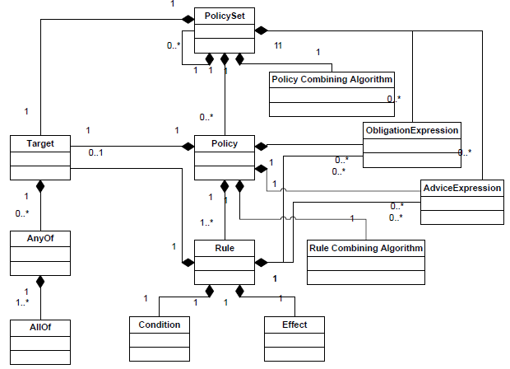

Figure 4 XACML Policy Language Model

The XACML is XML-based declarative policy language for defining access control policies and a related processing model which permits the specification of authorizations as rules. Furthermore, XACML is a generic framework recognized by OASIS standard[6] for access control which ideally provides expressiveness, modularity, interoperability and efficiency [16][17]. It is a declarative language for the specification of authorizations as rules. To maintain proper authorization between different users and resources, we will design and implement a series of XACML policies as shown in Appendix IV and V. The policies are defined and written by specified business rules and guidelines for access control to the system. XACML standards address and define how security authorization requests are handled internally. Apart from processing the authorization requests and it also defines the mechanism to perform a complete analysis of rules, policies, and policy sets to come up with a precise decision. To make it work seamlessly through dynamic changes to its run-time environment, react and adapt to the rapid changes in process execution.

In this security model of the adaptive software application, we propose a separation of code and authorization policy by utilizing the Extensible XACML and making use of ABAC. This is beneficial when regulations or corporate policies change then we can just centrally manage authorization rules without touching individual application source code. This helps the system to make accurate authorization decisions and also makes the application more adaptive with the frequent organizational changes without looking deep into the code. This is how we can centralize where the software changes need to be made rather following code-level tracing. However, XACML policy files include all rules/policies for the application which can have great security implications. Simple mistakes while writing wrong policy rules can grant unauthorized access and deny legitimate access to the system. Restrictive authorization and administration can be handled by the implementation of XACML security policies based on attributes; that can establish who can view, edit, and authorize specific parts of the proposal. An attribute is a property of an object; an authorization credential is a statement or assertion about an attribute. In particular, a credential must be based on defined attributes for a subject and during each action which validates and matches the pre-defined policy constraints.

As shown in Figure 4, XACML Policy Language Model compose of many components. The main elements of the XACML Policy Language model are:

1. Policy Sets consists of one or more policies.
2. Policies: A policy includes a set of rules, a declaration for applicable rule-combining algorithms, a set of obligations and advice, and a target.

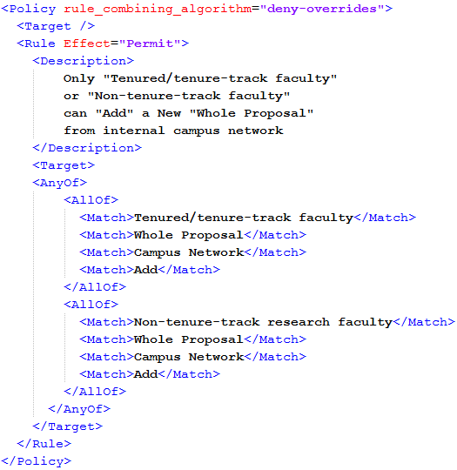

Figure 5 Basic XACML Policy Format

1. Rules: The most elementary unit of policy. Policy can comprise of one or many rules that can evaluate to *Permit, Deny, Indeterminate*, or *Not Applicable*.

An example of an XACML rule as in GPWfMS, can be expressed and represented in the human readable format as following:

*Any Tenured/ tenure-track faculty or Non- tenure-track faculty can add/create a new proposal only from internal network of the organization i.e. campus network. The subject attributes include ‘Tenured/ tenure-track faculty’; the action attribute is ‘Add’ and the resource attribute is ‘Whole Proposal’ and environment attribute is ‘Campus Network’. This rule stipulates that the request of a Tenured/ tenure-track faculty or Non-tenure-track faculty to create a new proposal will be granted only when he is doing so from within Campus network.*

Each access control rule consists of a condition, an effect, and a target as shown in Figure 5.

* Conditions are statements about attributes that can evaluate either True, False or Indeterminate.
* The effect return value Permit or Deny based on the satisfied rule.
* Target in policy helps in determining whether or not a rule is relevant for a request.
* As a policy can have multiple rules, it is evident that it can generate conflicting decisions based on different conflicting rules. To minimize that risk Rule-combining algorithms are used which resolve such conflicts and always try to outcome only one decision per policy.

The policy driven nature of the decisions requires that the decision-making capability is externalized from systems/applications/services and not be embedded within the code. The final decision is based on information about the subject, resource, environmental, and more hidden contextual information, that are often expressed as attributes and their corresponding values.

* **Subject**: position type, proposal role (PI, Co-PI, senior personnel).
* **Action**: add, save, edit, delete
* **Resource**: proposal datasheet section or whole proposal
* **Environment**: campus network, IP address, date time, mobile devices

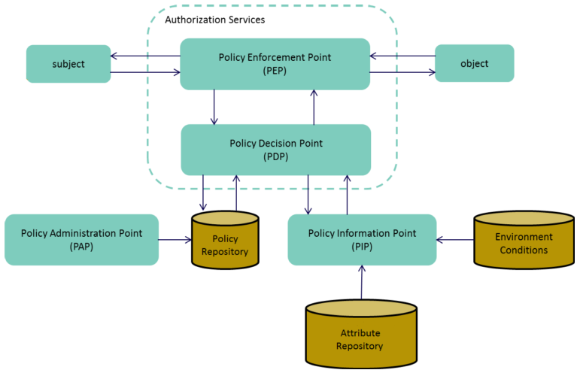  
The architected solution can be viewed as interactions of three top-level components. The reference architecture as shown in Figure 7, depicts all the logical components of XACML and their internal interactions.

Figure 7 High Level Design of XACML Enforcement Architecture

* The policy administrator defines and manages policies and policy sets at the Policy Administration Point (PAP).
* Policy Information Point (PIP) behaves as a metadata of attribute values (i.e. a resource, subject, environment conditions).
* XACML supports a variety of underlying infrastructures for policy and attribute storage. The policy repository stores the rules, policies, and policy sets that are used for access control.
* The Policy Decision Point (PDP) analyzes the resource access request with the matching rules, policies, and policy sets.
* The Policy Enforcement Point (PEP) forwards the incoming request for access or authorization decision to the XACML context handler with a predefined format that specifies the details about the attributes of the subjects, resources, actions, and the environment.
* Once the policy is evaluated successfully, the PEP will either permit access to the service requester for the requested resource or deny the access. Also, it executes associated obligations and advice if any.

In GPWfMS, A request for authorization lands at the PEP. The PEP formats an XACML correct request using the context of the proposal data and then sends it to the PDP, which evaluates the request and sends back the decision in response. The decision response can either allow the access request or deny it. The response also returns associated obligations and advice to be enforced. This new concept of constrained tasks to be followed before or after a request makes the software more secure and user more accountable. The key areas of concern for this proposed solution are Proper Authorization, Obligations, and Delegation of Authority.

### **Database**

Contained within this system is a database that stores relevant subject’s information. To manage the attributes of every subject and object, they must have corresponding entries in a database that allows attribute retrieval and comparison. The proposed dynamic architectural solution demands to generate, storing and analyzing more information with increasing speed and scale so to overcome such data-driven requirements we choose MongoDB[7] as the best suited No-SQL backend database.

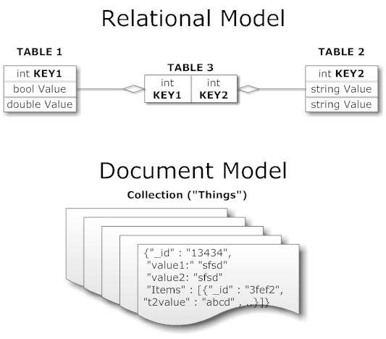

Figure 3 Relational vs. Document Database Model

As shown in Figure 3, traditional ‘relational’ database model stores information in hierarchical rows and columns in a tabular format. However, such mappings and relationships are impossible in big and messy dataset harvested from vast and concurrent data streams that are evident in such workflow system. Besides, MongoDB is more Document- Oriented where each document is stored as JSON objects and stored as Attribute-value pairs that make it easy to retrieve and process data and also more human readable and scalable.

Three primary database collections are needed for our purpose *Proposals*, *Users,* and *Notifications*. The User database collection contains the detailed information of a user as well as information necessary to authenticate securely access him with the system.

User information includes the following data:

* *User account data*: A user account name and password.
* *User detail information*: A user’s given names, contact information (such as addresses, phone numbers, and email addresses), and departmental position/ role information.

The Proposal database collection contains information for a proposal including personnel information related to it. The information of proposal includes:

* *Project information*: Proposal specific information, such as the project type, title, date related information.
* *Financial information*: Budget details, sponsorship information, cost sharing information.
* *Investigator information*: Details about PI’s, Co-PI’s, senior personnel
* *Signature information*: Signatures and notes from corresponding authorized users.

The Notification database collection stores information regarding the recent changes to the data and the corresponding user whom the system need to notify.

### **Morphia**

Morphia[8] is a lightweight library for mapping Java objects to and from MongoDB database. Morphia is an Open Source Fluent Query API that uses annotations and standards to interact with code and database. It adds a layer of abstraction between Datastore and Data Access Object (DAO) from the application. It eases the working with data in Java as it creates a data persistence interface in between. Morphia is MongoDB’s Java Persistence API (JPA[9]) which handles data access operations with less code.

### **Balana**

Balana[10] is an open source Sun's XACML Implementation by WSO2[11] that supports XACML 3.0 that allows creating Policy Decision Point instance.

## 5.2 Obligation

In modern WfMS, there is a need to have a connection between individual rights and embedded responsibility or between privileges and associated obligations. This is very useful to solve accountability problem in Structured and Collaborative environment. We seek to implement XACML 3.0’s ability to fulfill an obligation which can be modeled as like pre and post conditions on each step of the workflow multi-layered state machine. Latest Obligation Specification that is extended in XACML 3.0 defines that each definition of the obligation contains a unique identifier and contains zero or many lists of parameters, each with a locally unique name and the data type. XACML 3.0 allows us to describe an obligation method and its parameters as an attribute assignment so the actual definition of its syntax and semantics can be implemented quickly. Even though, the XACML policy language is very flexible; there is currently no generic method to specify the obligations send from PDP to PEP. It has no standard conceptual model for obligations and their enforcement [18]. Although, this is an important issue especially to support privacy, and advanced tracking of data flow this is quite neglected and not properly handled by XACML. Currently, the XACML standard does not provide a way to examine further the enforcement of an obligation and neither check its consistency and accuracy.

Depending on the nature of the obligation, an obligation could be seen as an additional restriction on the access right. As adding an obligation constraint to a policy or rule, one issuer can restrict the authority of another issuer which is important while using delegated XACML rules. An XACML obligation is an action to be performed when a particular event is triggered. To specify obligations in access control policies is more secure and flexible than hard-wired in code-level. We can implement Obligations in response to each user or program actions. Obligation statements define commitment or promise made by one entity to another entity. A list of obligations which have the same effect associated with an action is evaluated and returned to the PEP. Obviously, there can have conflicts among a set of obligations that means we need to keep account of relations between obligations to make it more accurate. The PEP is responsible for decoding and checking for each response for any obligations constraints and negotiates to enforce these obligations. For this, PEP keeps track of the obligations’ state and enforce the restrictions.

For instance, a mere obligation can be to send a notification email when a proposal is ready to be reviewed by the next person in the workflow. After her approval or disapproval, other associated users also get a notification that her task is completed and workflow proceeds to next level. This process can be done autonomously by the system so it can lessen the workload for a user involved and assure less intervention is needed to manage the business process and can improve application performance and stability, also software maintainability. This ability to configure the obligation fulfillment requirement externally enables an administrator to activate or deactivate such security requirements dynamically without restarting or redeploying the running service.

## 5.3 Delegation

Apparently, the delegation of a task to another authorized user is a very useful real-world situation by which workflow continues to successful completion either in the case of user or resource unavailability or overloaded with tasks. The delegation of authority is an important business rule in an enterprise or organization where diverse users need to perform dynamic business processes in a heterogeneous computing environment. Without DOA tasks cannot be divided among users so users would soon become overloaded with pending tasks. For example, considering our use case application GPWfMS, the Department Chair may have to leave for a business trip; his approval work should be done by an Assistant Department Chair with whom he trusts. Therefore, he needs to give the person his permission to carry out the necessary task. Also, he is allowed revoke this temporarily delegated rights from his assistant once he comes back or anytime he wants. If such feature is not implemented in the workflow system, this can delay the overall task executions and can easily violate time constraints on the workflow impairing successful completion of the workflow. A delegation of Authority is a suitable approach to handling such exceptions and to ensure alternative execution routing path to the workflow process that makes WfMS more flexible and efficient. However, on the other hand, this decentralization in authorization can impose severe security risks to the organization by exposing high-level privileges to individual users. The basic idea behind DOA is that an authorized entity is allowed to forward his authority to another active object so that later can carry out some tasks on behalf of the former.

In the field of access control, it is very crucial to have a delegation that helps to simplify the administrator task and to coordinate collaborative work securely, especially with the increase in shared information and distributed systems. Delegation and Revocation are important concepts that are essential for modeling and reasoning about dynamic distributed systems. Delegation is an essential and desirable feature in any modern enterprise and to model that constraint into a real-world software is a challenge because it brings lots of complexities, risk and privacy issues associated with individual user’s privileges and permissions. Trust gives a notion of achieving such security constraints [19]. If this trust level is exploited, then that can be the point of security attacks and poses a threat to whole business.

In RBAC, it demands a significant number of delegation be created and managed as the number of roles and resources increase. However, this can be minimized by using ABAC model and also reduce the complexity of security administration. While delegation is an important feature of any dynamic business, it is necessary to monitor and make sure none of the security constraints are violated. Assignment of delegation can be based on time, workload and users’ attributes. The dynamic and decentralized delegation distributes the privileges that make the workflow more flexible and scalable. Authority is often granted to an alternative subject if the primary subject is absent for an extended amount of time, and someone must be available to act on former’s behalf. This situation typically occurs if there are not enough users to process the workload or user wants to offload his increased tasks with his sub-coordinates. At such situation, it is necessary to add additional resources to the workflow system. Delegation allows global administrators to delegate constrained administrative rights to local administrators. Thus, by dynamic delegation workflow system offers the user an ability to change the routing process during execution time preventing obstruction of the workflow. This will make the workflow continuous and unobstructed even in the absence of a particular user at any stage. This helps the organization to fully utilized the available resources. By allowing users to provision, manage, and de-provision their privileges unify the management of users, activities, and other resources. Such multi-domain user to dynamic user delegation of authority is desired in any adaptive and dynamic workflow system.

While provisioning delegation of authority, it is required that it should have minimum errors and ensures uniformity with all user permissions besides making delegation a simple, risk-free activity. Recent work [20] tries to add delegation extension to XACML 3.0 to express the right to administrate XACML policies within XACML itself using Administration and Delegation Profile. The ability to delegate administrative rights in XACML is new as of XACML 3.0. The delegation profile draft explains how to negotiate for the right to issue a policy, but they have not provided any rules for removing a policy. So we need to adopt a secure and flexible revocation model in WfMS, which gives a delegating user i.e. delegator power to revert the privileges from the one he has delegated i.e. delegatee. Both delegation and revocation need to take account of time constraints, so our system must account for this provision. As delegation can cause a critical security threat to a workflow system, provision and mitigation approaches need to be implemented on any WfMS. The key issue is evident in the real world scenario such as how to model the DOA in which one user can transfer his/ her authority to another user for a given period or a particular resource and then revoke it back.

# Project Timeline

Oral presentation: April 2016

Project Report: October 2016

Final oral defense: December 2016

|  |  |  |
| --- | --- | --- |
| **Date** | **Activity** | **Status** |
| August 2015 | Requirement Analysis and specification refinement | Done |
| September 2015 | Create and Design backend database using MongoDB | Done |
| November 2016 | Create REST services using JAX-RS, Morphia and Java and jUnit test cases | Done |
| December 2016 | Designing the frontend and backend page layout | Done |
| January 2016 | Integrate the REST web services with the web application | Done |
| February 2016 | Implementing Balana framework to the system and testing | Done |
| March 2015 | Implementation of approvable workflow steps via user’s signatures | Done |
| April 2016 | Implementing the XACML policy rules to each action | Done |
| May 2016 | Implement the model for DOA and Obligations and verify the working conditions | On-going |
| June 2016 | Design the Model to implementing the Delegation of Authority based on XACML 3.0 | N/A |
| August 2016 | Proof of Concept Testing and valid Measurement of the prototype | N/A |
| October 2016 | Documentation write-up, Final presentation, and thesis defense | N/A |

# Bibliography

[1] S. Lakkaraju and D. Xu, “Integrated Modeling and Analysis of Attribute Based Access Control Policies and Workflows in Healthcare,” *2014 Int. Conf. Trust. Syst. their Appl.*, pp. 36–43, 2014.

[2] L. Sainan, “Task-role-based access control model and its implementation,” *2010 2nd Int. Conf. Educ. Technol. Comput.*, pp. V3–293–V3–296, 2010.

[3] Y. Liu, K. Xu, and J. Song, “A task-attribute-based workflow access control model,” *Proc. - 2013 IEEE Int. Conf. Green Comput. Commun. IEEE Internet Things IEEE Cyber, Phys. Soc. Comput. GreenCom-iThings-CPSCom 2013*, pp. 1330–1334, 2013.

[4] V. C. Hu, K. Scarfone, and R. Kuhn, *NIST Special Publication 800-162 DRAFT - FINAL Guide to Attribute Based Access Control ( ABAC ) Definition and Considerations NIST Special Publication 800-162 DRAFT - FINAL Guide to Attribute Based Access Control ( ABAC ) Definition and Considerations*. 2013.

[5] W. Tolone, G.-J. Ahn, T. Pai, and S.-P. Hong, “Access control in collaborative systems,” *ACM Comput. Surv.*, vol. 37, no. 1, pp. 29–41, 2005.

[6] Y. Lu and L. Zhang, “Domain administration of task-role based access control for process collaboration environments,” *5th Int. Conf. Inf. Assur. Secur. IAS 2009*, vol. 1, no. 1, pp. 643–647, 2009.

[7] J. Zhang, J. Sun, N. Li, and C. Hu, “Based on Mul-weighCted Roles in Worklsow System,” pp. 3–8, 2005.

[8] D. Hollingsworth, “Glossary, Terminology and Glossary, 3rd Edition. Document No WFMC-TC-1011. Workflow Management Coalition. Winchester, 1999,” *ReVision*, 1999.

[9] K. Stoilova, T. Stoilov, K. P. Stoilova, and T. a Stoilov, “Evolution of the workflow management systems,” *Int. Sci. Conf. Information, Commun. Energy Syst. Technol.*, pp. 225–228, 2006.

[10] L. Wang, “Research of TRBAC model and the application in library management,” pp. 1–3, 2010.

[11] W. Viriyasitavat and A. Martin, “A survey of trust in workflows and relevant contexts,” *IEEE Commun. Surv. Tutorials*, vol. 14, no. 3, pp. 911–940, 2012.

[12] S. Chaari, F. Biennier, C. Ben Amar, and J. Favrel, “An authorization and access control model for workflow,” *First Int. Symp. Control. Commun. Signal Process. 2004.*, pp. 141–148, 2004.

[13] E. Bertino, E. Ferrari, and V. Atluri, “The specification and enforcement of authorization constraints in workflow management systems,” *ACM Trans. Inf. Syst. Secur.*, vol. 2, no. 1, pp. 65–104, 1999.

[14] D. Georgakopoulos, M. Hornick, and A. Sheth, “An overview of workflow management: From process modeling to workflow automation infrastructure,” *Distrib. Parallel Databases*, vol. 3, no. 2, pp. 119–153, 1995.

[15] R. S. Sandhu, E. J. Coyne, H. L. Feinstein, and C. E. Youman, “Role-Based Access Control Models,” *IEEE Comput.*, vol. 29, no. 2, pp. 38–47, 1995.

[16] R. Abassi, F. Jacquemard, M. Rusinowitch, and S. G. El Fatmi, “XML access control: From XACML to annotated schemas,” *2010 2nd Int. Conf. Commun. Networking, ComNet 2010*, no. October 2015, 2010.

[17] M. Lischka, “Dynamic obligation specification and negotiation,” *Proc. 2010 IEEE/IFIP Netw. Oper. Manag. Symp. NOMS 2010*, pp. 155–162, 2010.

[18] D. Chadwick, “Obligation Standardization,” *Europe*, pp. 1–11, 2009.

[19] G. Aucher, S. Barker, G. Boella, V. Genovese, and L. Van Der Torre, “Dynamics in delegation and revocation schemes: A logical approach,” *Lect. Notes Comput. Sci. (including Subser. Lect. Notes Artif. Intell. Lect. Notes Bioinformatics)*, vol. 6818 LNCS, pp. 90–105, 2011.

[20] Oasis, “eXtensible Access Control Markup Language,” *OASIS Stand.*, no. February, p. 141, 2005.

**Appendix**

1. **State Diagram of GPWfMS**

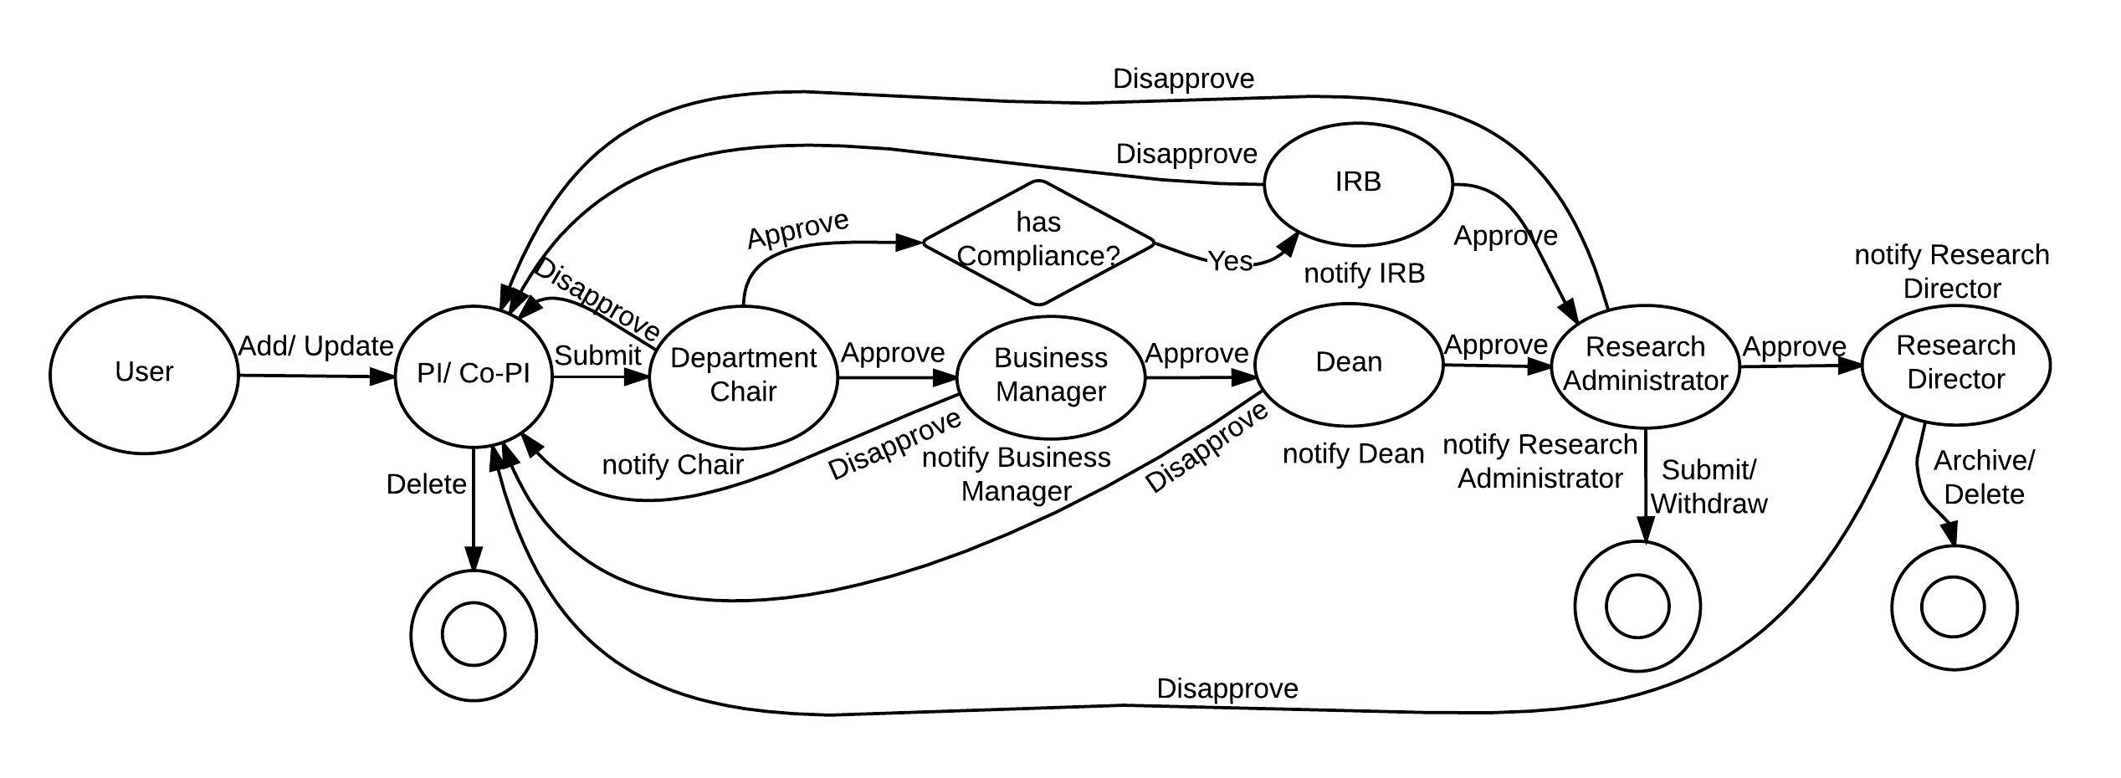

1. **Use Case Diagram of GPWfMS**C:\Users\Milson\Downloads\GPMS Case Model (2).png
2. **UML Sequence Diagram**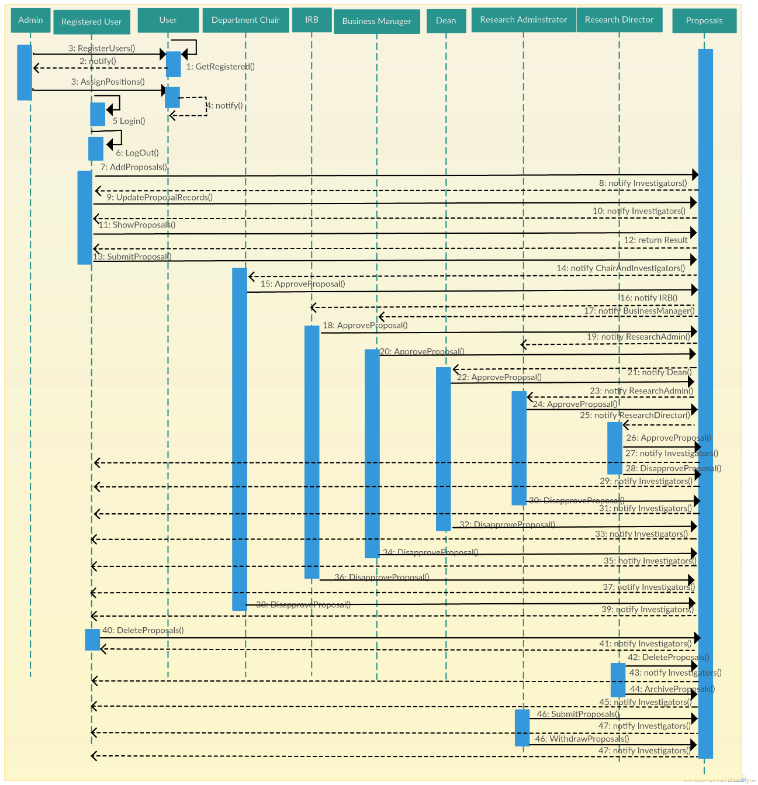
3. **Policy in XACML**
   1. Only "Tenured/tenure-track faculty" or "Non-tenure-track research faculty" can "Add" a "Whole Proposal"
   2. "Teaching faculty", "Research staff", "Professional staff", "Administrator" cannot "Add" a "Whole Proposal" unless delegated by faculty
   3. "PI" can "View" proposal "Audit Log"
   4. "Department Chair" can "Approve" a "Whole Proposal" when ApprovedByDepartmentChair = READYFORAPPROVAL

With Obligations of logging and Notify via email to all Investigators of a proposal

1. **ABAC Policies with Obligations**



1. **OSP-Proposal-Data-Sheet**

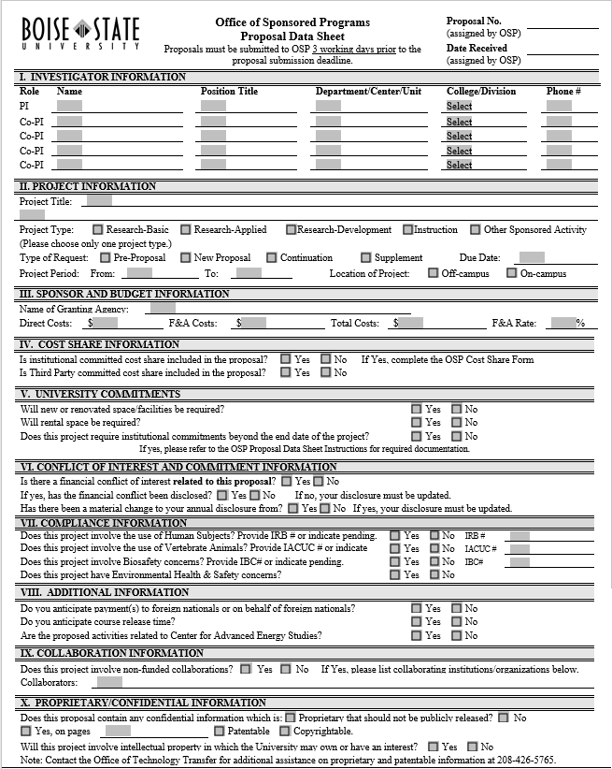

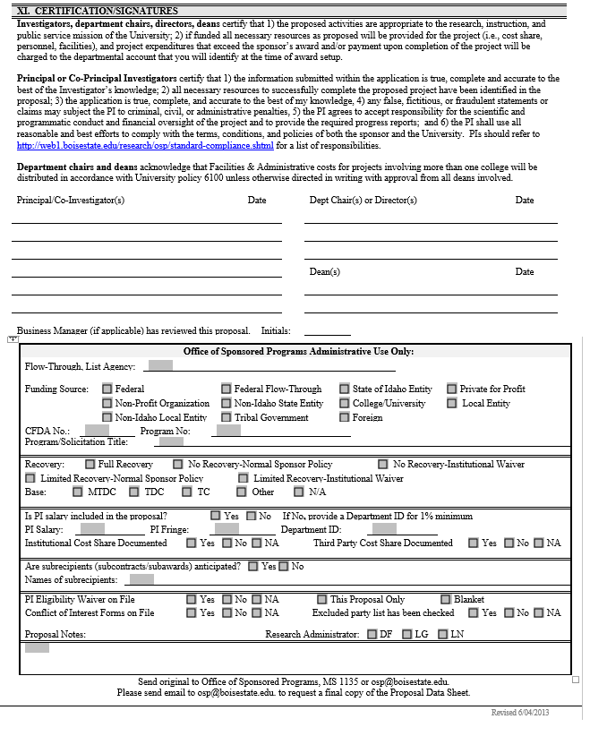

1. https://en.wikipedia.org/wiki/Application_programming_interface
2. https://jcp.org/en/jsr/detail?id=339
3. https://en.wikipedia.org/wiki/Representational_state_transfer
4. http://junit.org/junit4/
5. https://en.wikipedia.org/wiki/Create,_read,_update_and_delete
6. https://www.oasis-open.org/standards
7. https://www.mongodb.org/
8. https://github.com/mongodb/morphia
9. https://en.wikipedia.org/wiki/Java_Persistence_API
10. http://xacmlinfo.org/category/balana/
11. http://wso2.com/